- Successfully running on Swagger UI
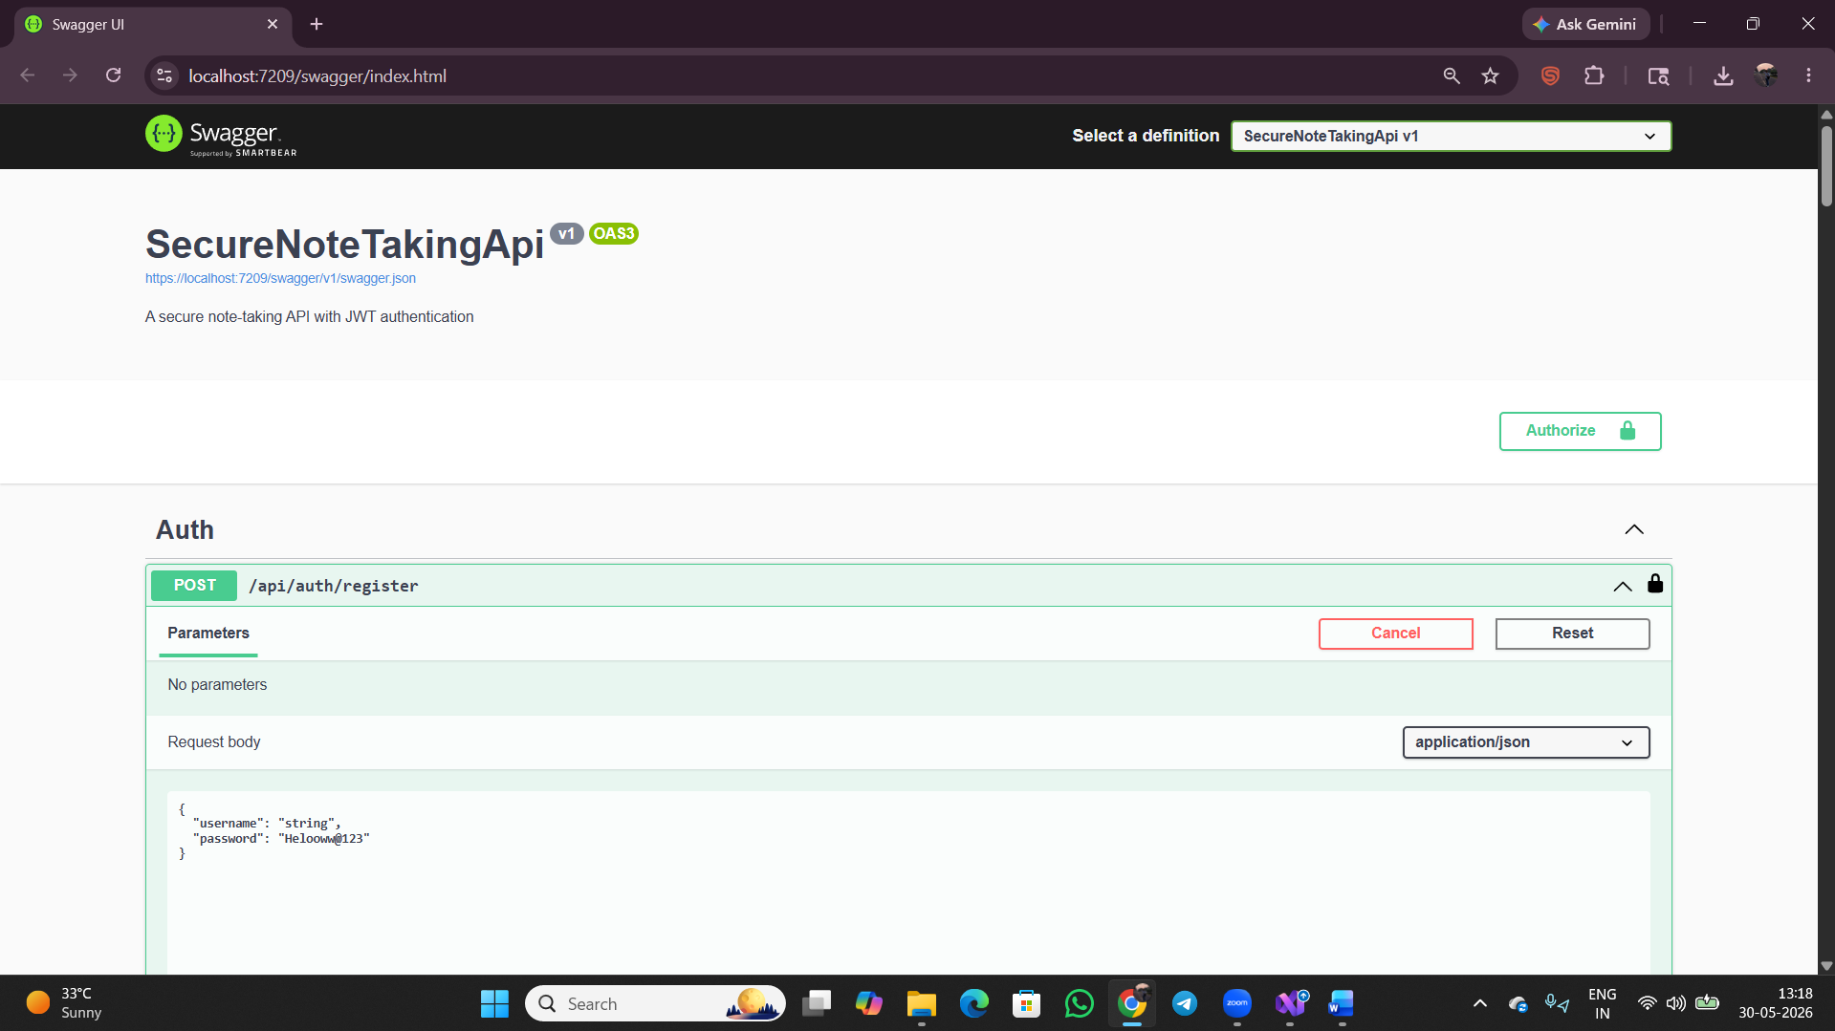
- Successful POST request and message “User is registered successfully. Please log in”.
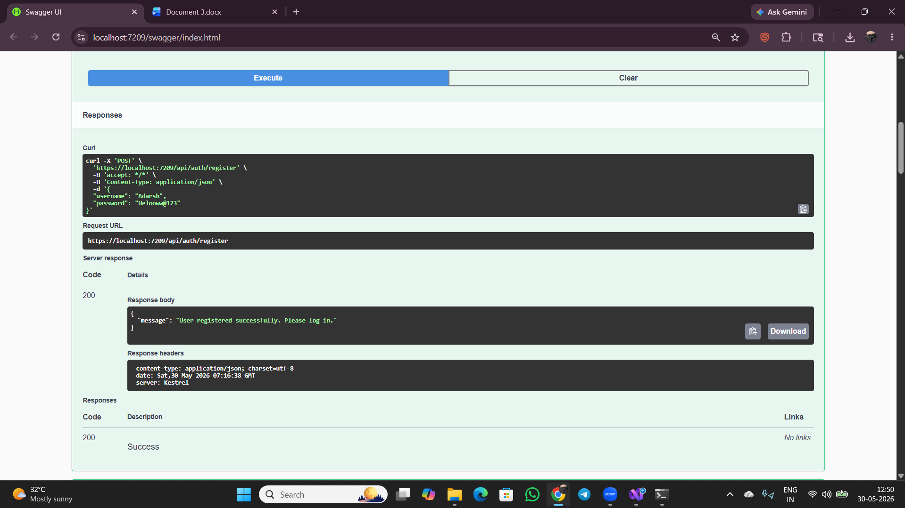

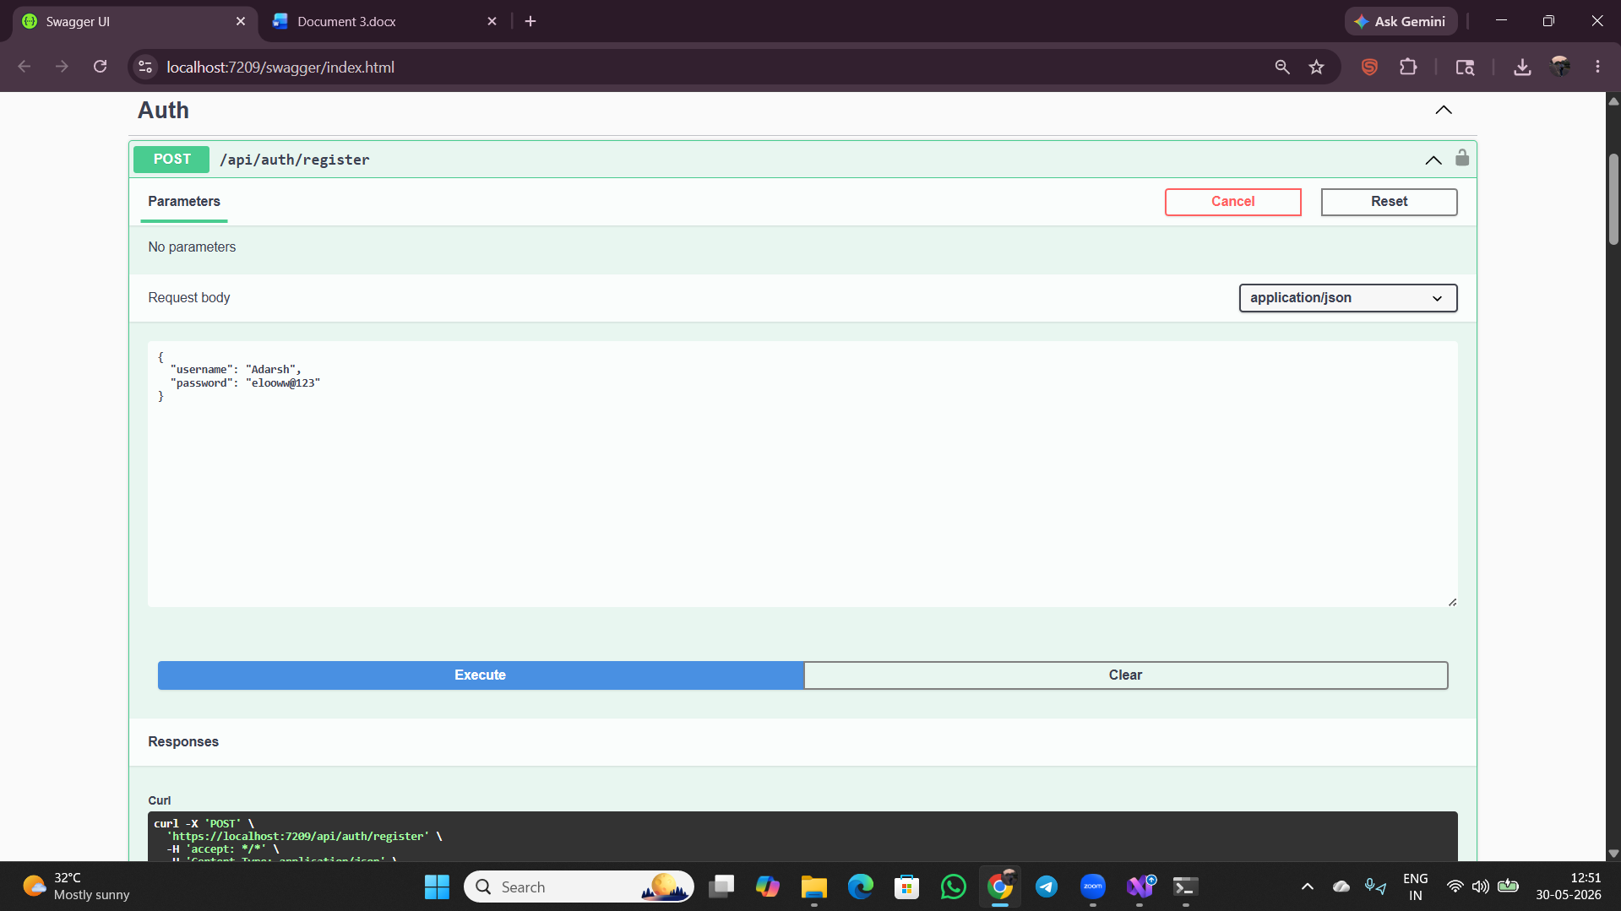
- Showing failed POST request with 400 error response indicating password is wrong
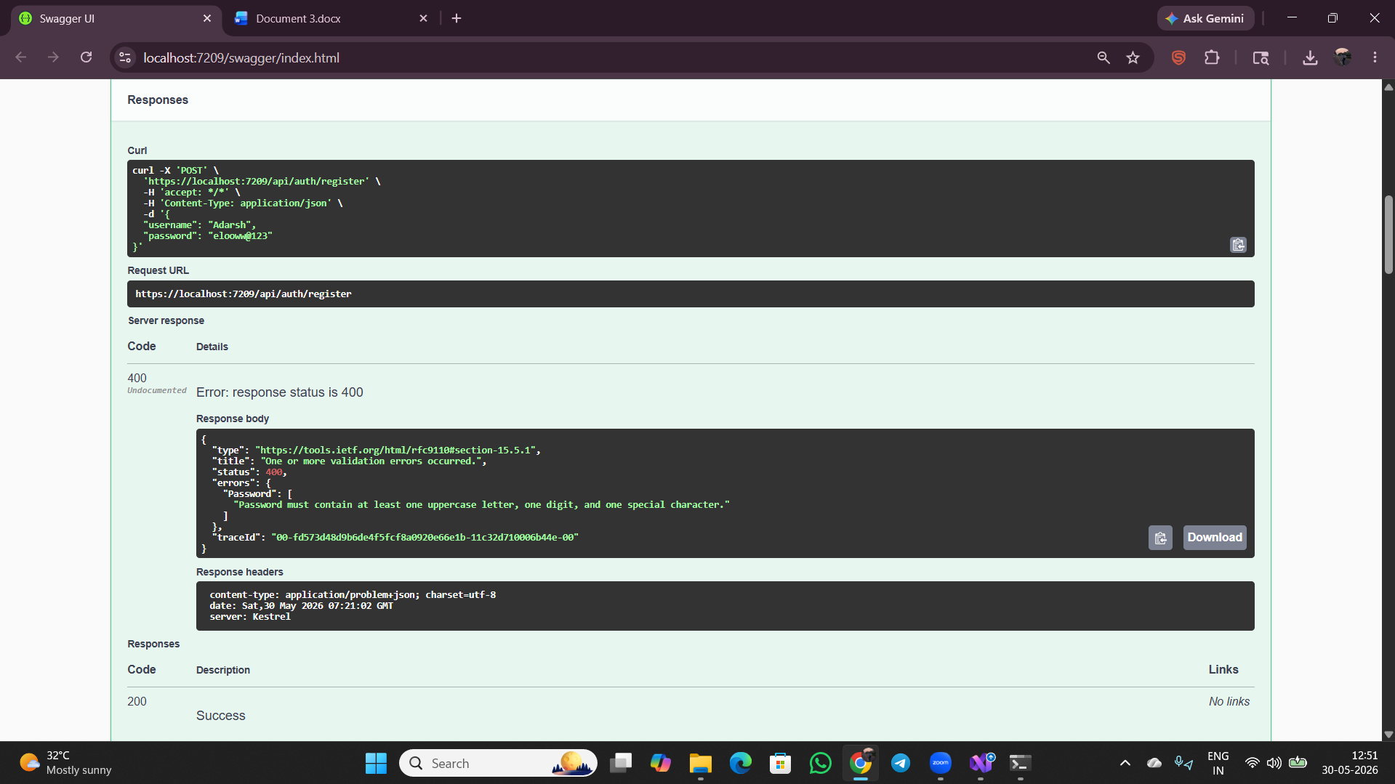

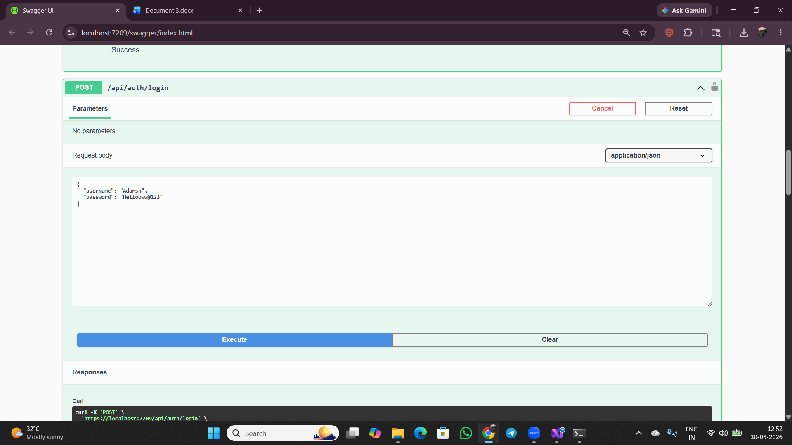
- Showing a failed POST with a 401 response returning "Invalid username or password
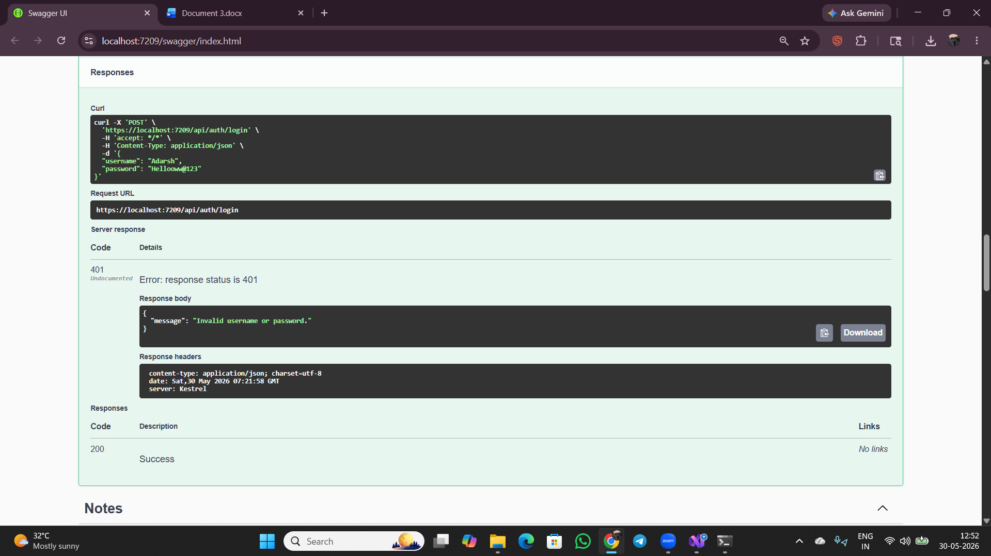
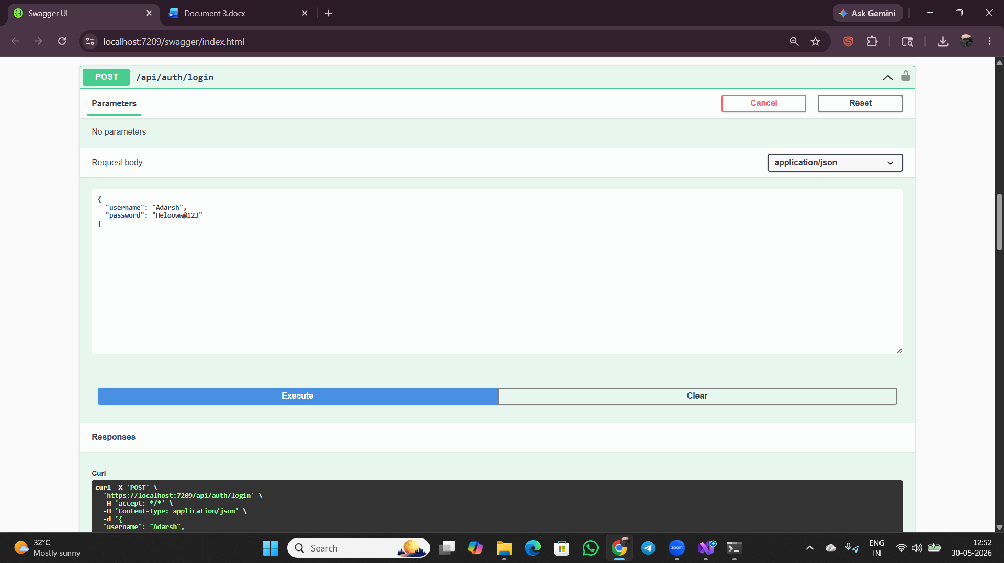
- Showing a successful POST returning a 200 response with a JWT token, expiry info, and username "Adarsh" in the response body.
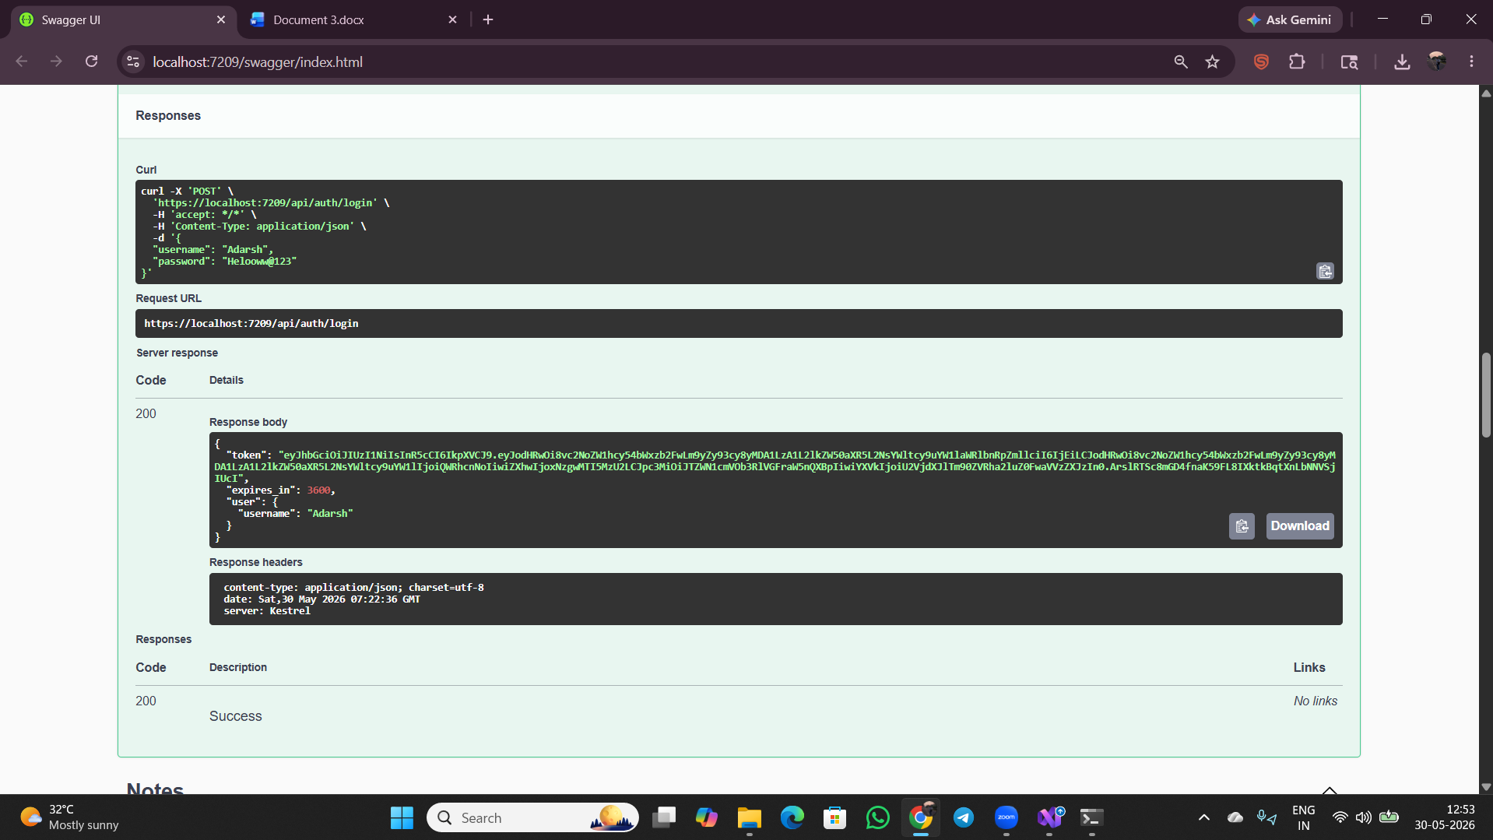

- Showing the POST form (under the Notes section) with a body containing "title" and "content" string fields.
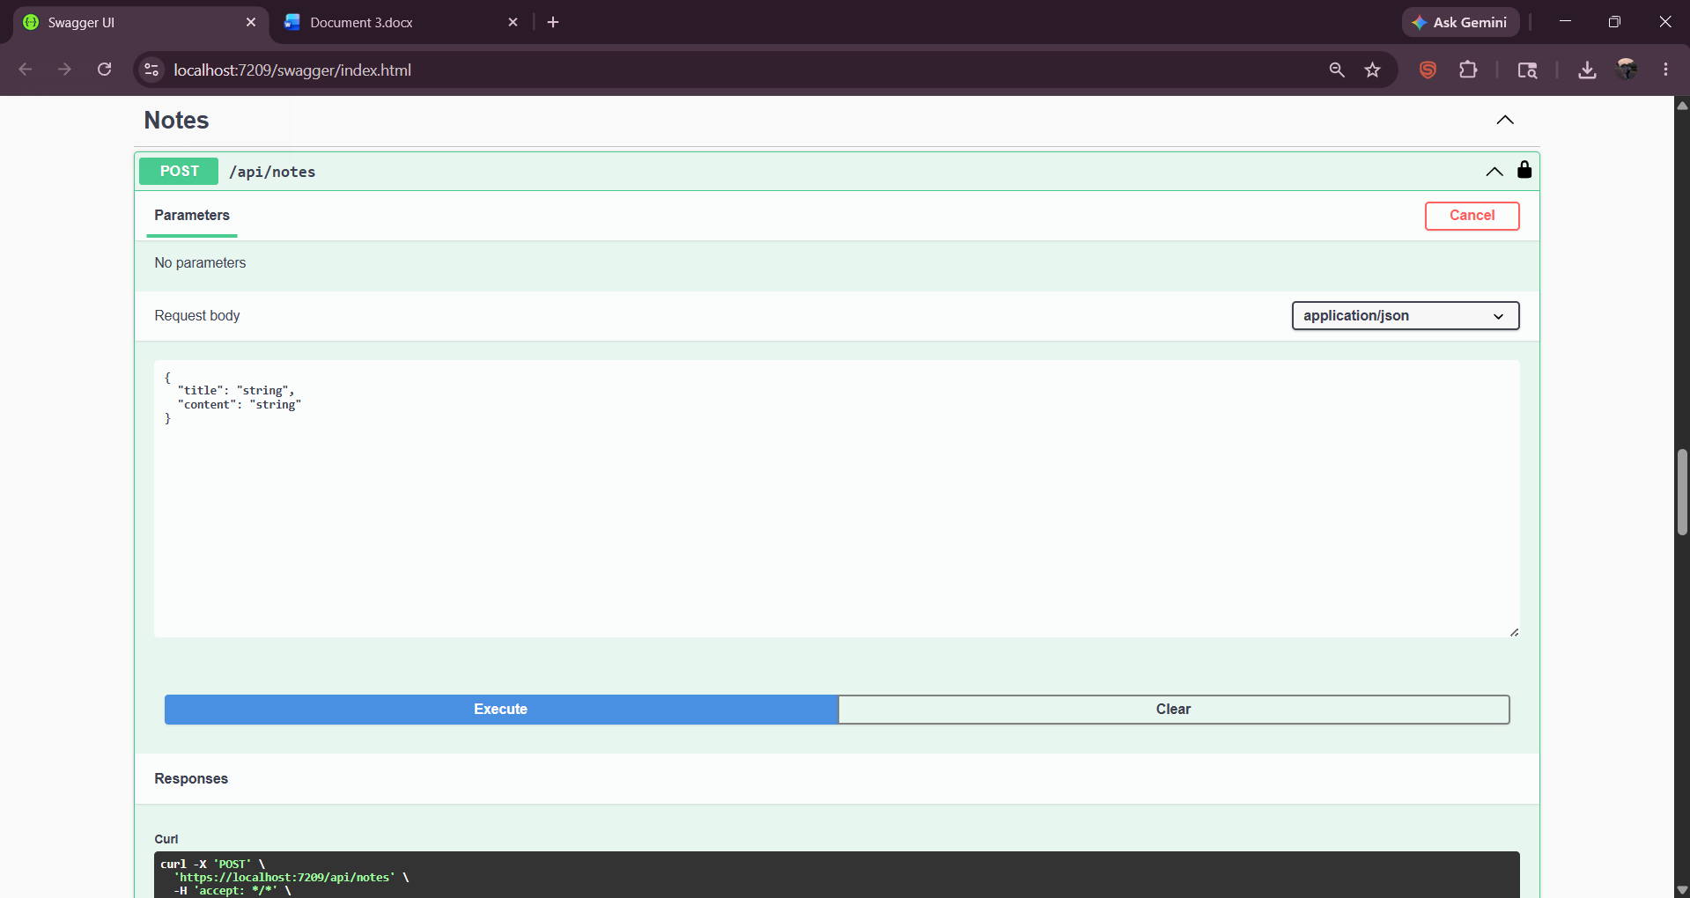

- Showing a successful GET request returning a 200 response with a notes array containing id, title, and content fields.
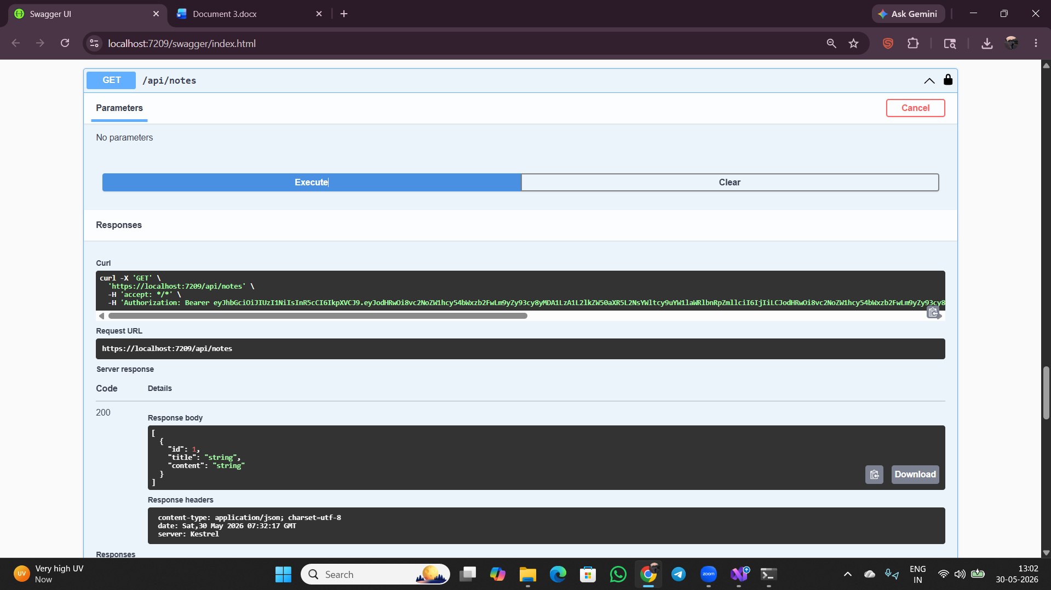
- Displaying the PUT /api/notes/{id} endpoint form with path parameter id=1 and a JSON request body for updating a note's title and content.
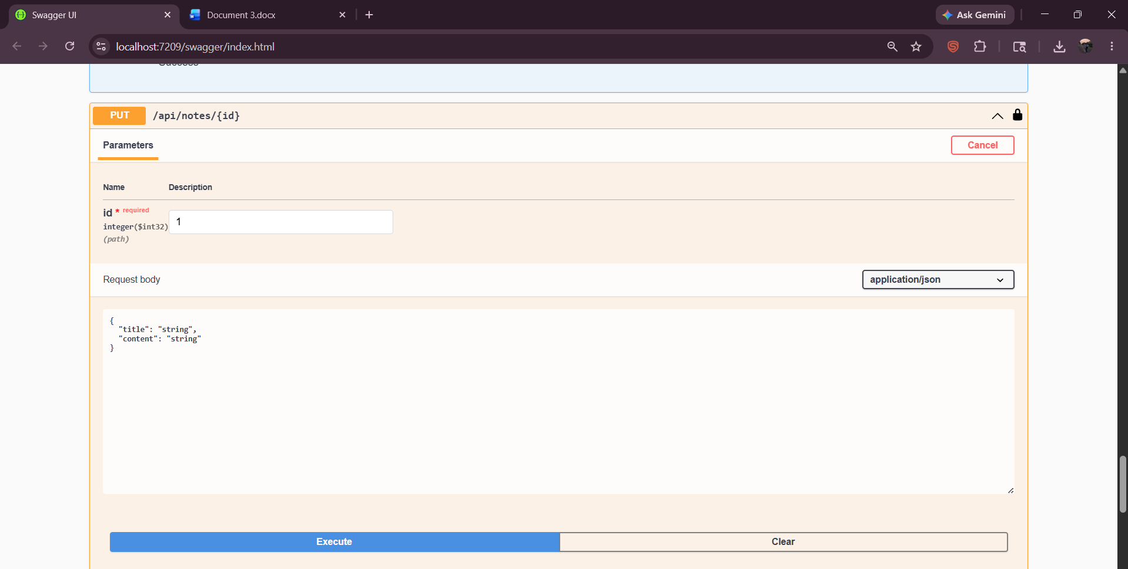

- Showing a successful PUT request returning a 200 response with the message "Note updated successfully."
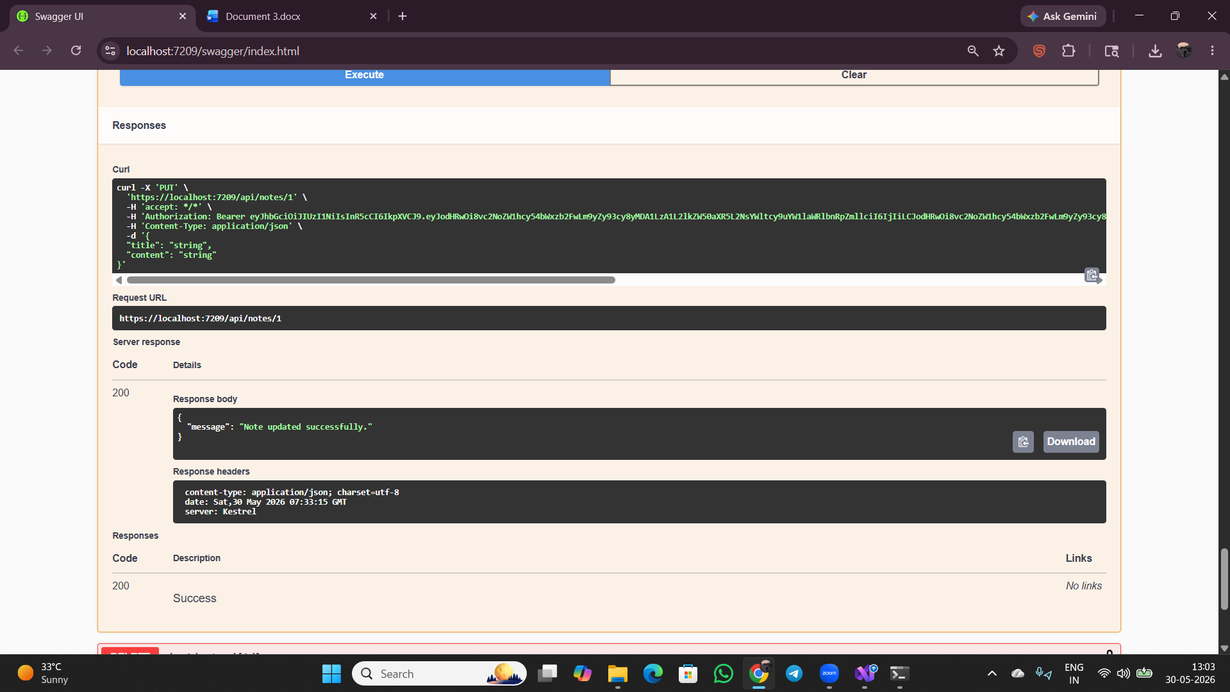

- Showing the DELETE endpoint with id = 1, returning a 200 response with message
“Note deleted successfully”
